CASE TOOLS LAB
PROJECT
ON
LECTURE HALL
CLASS SCHEDULE

SUBMITTED BY:

HARSHVARDHAN KUMAR
ROLL NO: 205112087

TABLE OF CONTENTS

- PROBLEM STATEMENT
- SOFTWARE REQUIREMENT SPECIFICATION
- PROCESS MODEL
- OBJECT MODEL DIAGRAM
- SEQUENCE DIAGRAM
- USE CASE DIAGRAM
- STATECHARTS
- ENTITY RELATIONSHIP DIAGRAMS
- DATA FLOW DIAGRAMS

PROBLEM STATEMENT

This is the project where we can maintain the class schedule in the lacture hall.
So we can see the classroom schedule for class conduct. The required of the project is to search the class room for class conduct . Now we first we search which classroom has no class and then take permission for lecture hall adminisrator. So it take so much time to search in classroom.And there is one more problem if any class is alredy decided for that room and other class use that classroom that time its again create a problem the use of that project we directly search from database for classroom and then we take the permission from lecture hall administrator .So it take less time and essy to use.for that frist we create a databse for each class which is conduct in the lecture hall.And take class entry time and leaving time from the classroom.

SOFTWARE REQUIREMENT SPECIFICATION

- INTRODUCTION

  - Purpose

The origin of most software systems is in the need of a client, who either wants to automate the existing manual system or desires a new software system. The software system is itself created by the developer. Finally, the end user will use the completed system. Thus, there are three major parties interested in a new system: the client, the user, and the developer. Somehow the requirements for the system that will satisfy the needs of the clients and the concerns of the users have to be communicated to the developer. The problem is that the client doesn’t usually design the software or the software development process and the developer does not understand the client’s problem and the application area. This causes a communication gap between the parties involved in the development of the project.
The basic purpose of Software Requirement Specification (SRS) is to bridge this communication gap. SRS is the medium through which the client’s and the user’s needs are accurately specified; indeed SRS forms the basis of software development.
Another important purpose of developing an SRS is helping the clients understanding their own needs. An SRS establishes the basis for agreement between the client and the supplier on what the software product will do.
An SRS provides a reference for validation of the final product.

A high quality SRS is a prerequisite to high quality software and it also reduces the development cost.

The objective is to provide users with software with which they can interact and can get most of their initial work done and also for getting detailed information about judgment made on a case.

Acronyms

- DFD Data Flow Diagram
- ERD Entity Relationship Diagram
- SRS Software Requirement Specification

SYSTEM PROCESS MODEL
To solve a particular problem a software engineer or a team of software engineers must incorporate a development strategy than encompasses the process, methods and tools. This strategy is often referred to as a process model or a “SOFTWARE ENGINEERING PARADIGM”. The use of a particular process model or software paradigm is based on the nature of the application.

A software life cycle is the series of identifiable stages that a software product undergoes during its lifetime. A software life cycle model is a descriptive and diagrammatic representation of the software life cycle. A life cycle model represents all the activities required to make a software product transit through its life cycle phases. It also captures the order in which these activities are to be undertaken. A life cycle model maps the different activities performed on a software product from its inception to retirement.

Different life cycle models may map the basic development activities to phases in different ways. Thus, no matter which life cycle model is followed, the basic activities are included in all life cycle models though the activities may be carried out in different orders in different life cycle models. During any life cycle phases, more than one activity may also be carried out.
A process covers all the activities beginning from product inception through delivery and retirement. It addresses the broader issue of reuse, documentation, testing, parallel work carried out by team members and coordination with the customer.

A software application may be for an application of real time system, a database system, an operating system or a web based application. Primary advantage of using a life cycle model is that it encourages development of software in a systematic & disciplined manner.

Using a process model gives a good understanding of project to all the team members i.e. what to do & when? It prevents misinterpretations, helps in identifying inconsistencies, redundancies.

Some of them are given below: -

- Waterfall model

- Prototype model

- Iterative enhancement model

- Spiral model

- Rapid action development model (RAD Model)

- Fourth generation technique (4GT)

The following points states the need of a particular software paradigm for development of a software.

- To improve the quality of software.

- To increase the productivity of software development.

- To development of software on time.

- To produce a reliable software.

- To develop the software with in cost estimates.

Thus the above said discussion states that a software paradigm is very necessary to develop software.
So in our project we are following the Iterative model for the development of our project.

Iterative Enhancement Model: - This model provides the benefit of both Prototype and Waterfall model. The basic idea is that the software should be developed in increments, each increment adding some functional capability to the system until the full system implemented.

Requirement analysis and specification
Design
Coding and unit testing
Integrating and system testing
Maintenance
Feasibility study

ITERATIVE WATERFALL MODEL

OBJECT MODAL DIAGARAM

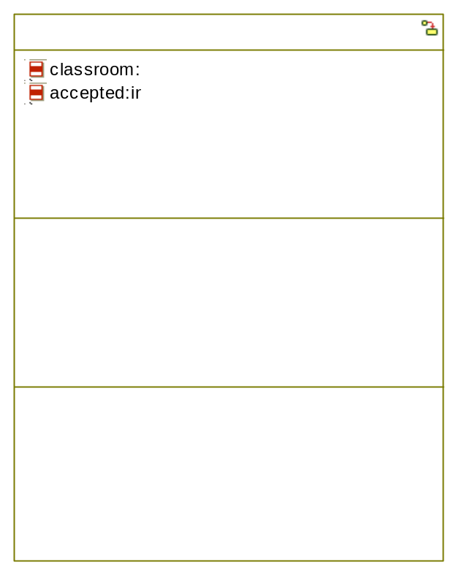

Sequence Diagrams:

lecture_hall_classes
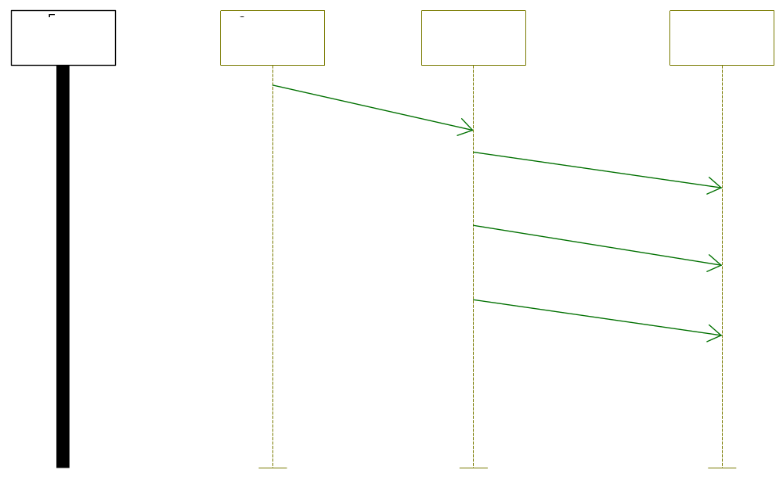

Use Case Diagrams:

lecture_hall_classes
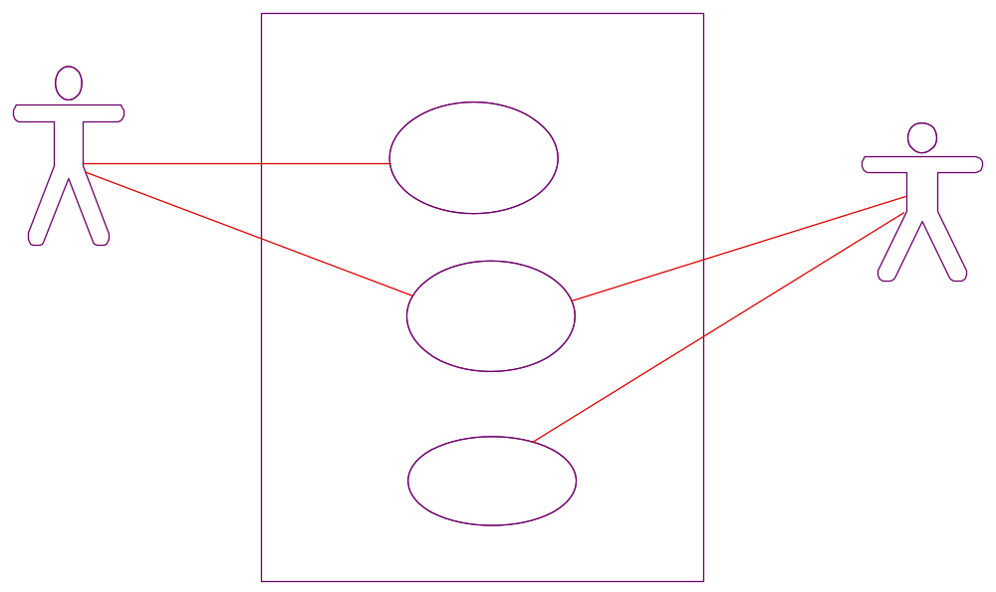

STATECHART
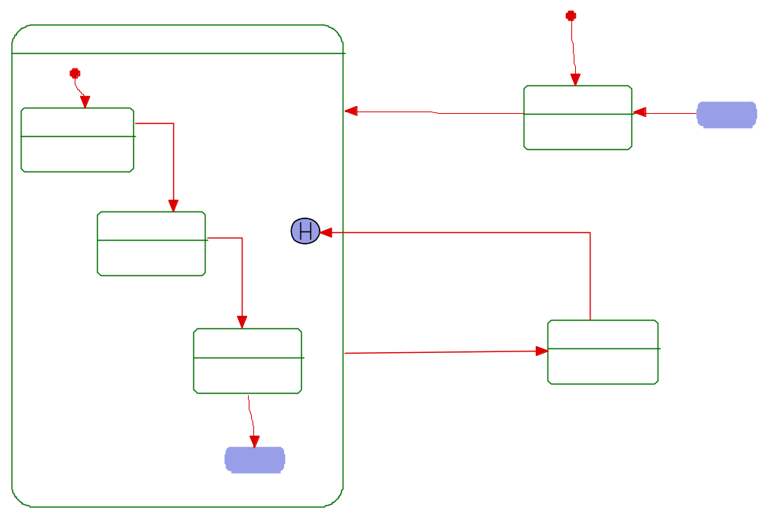

E R DIAGRAM FOR CLASS TIME TABLE

D.NAME

S.ADDRESS
S.PHONE NO

S.ID

S.NAME

D.ID

BRANCH
MEMBER OF

STUDENT

DEPARTMENT

ROOM NO
MANAGE
LECTURE HALL
ADMINISTRATOR
ROOM SEARCH
PERMISSION

LETURE HALL

classes
A.ID

DATA FLOW DIAGRAM FOR CLASS
TIME TABLE

Level 0:
SEARCH
EMPTY
ROOM

STUDENT

ROOMS

Level 1:

Cheak room database
EMPTY ROOM
SEARCHING
STUDENT

ROOMS
DATABASE

Ask permission accepted / reject

PERMISSION
SEARCH
S DATA
BASE

LECTURE HALL
ADMINISTRATOR
DEPARTMENT

Cheak rooms

cheak

correct

Cheak student database

STUDENT DATABASE

